[Skip to content](https://kurakar.wordpress.com/2013/03/04/isro-previous-paper-for-computer-science/comment-page-1/" \l "content)

[**My Blog**](https://kurakar.wordpress.com/)

**Just Another Blog**

**ISRO Previous paper for computer science**

Indian Space Research Organisation [ISRO] is engaged in application of Space Science and Space Technology for the development of society at large and for serving the nation by achieving self-reliance by indigenous developing capability to design and develop Space Transportation Systems and Satellites. ISRO offers the position of **Scientist/Engineer ‘SC’** in the pay band of **Rs.15600-39100 with grade pay Rs.5400/- (Group ‘A’ Gazetted Post)** to the young graduates in the following specialized fields

**Eligibility**

Eligibility for the above posts are mentioned as 65% during graduation. However, it is the minimum criteria. Mere 65% doesn’t make you eligible for written exam. There will be an initial screening for written exam based on your percentage and biodata. However last year (2011) it was 70% for computer science. The cutoff percentage will depends upon the total number of application, I think. This time, ISRO will publish key and candidates will get an opportunity to complaint if there is something wrong.

Last date of online application: **4/03/2013**

Link to previous year question paper(computer science)

click here for [2009](http://www.isro.org/pdf/CS-2009.pdf) cs paper

click here for [2008](http://www.isro.org/pdf/CS-2008.pdf) cs paper

click here for [2007](http://www.isro.org/pdf/CS-2007.pdf) cs paper

**Edit :**

**Lots of people are asking for ISRO-Computer Science Mock Test. A mock test is provided at** [**www.startmytest.com**](http://startmytest.com/exams/isro/)**. You may check it.**

**The written test will be conducted on 05-05-2013(Sunday) at ten venues viz Ahmedabad, Bangalore, Bhopal, Chennai, Guwahati, Hyderabad, Kolkata, Mumbai, New Delhi and Thiruvananthapuram**

ISRO 2011 CS Question paper. Courtesy: [Aravind Prasad](https://www.facebook.com/aravind.prasad.55)

[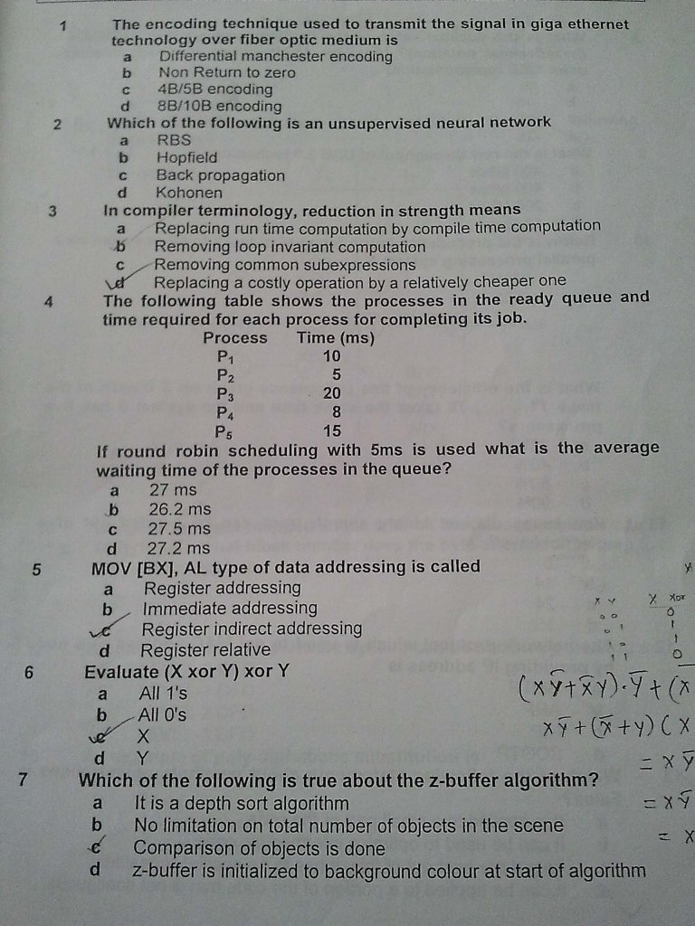](https://kurakar.files.wordpress.com/2013/03/1.jpg)

[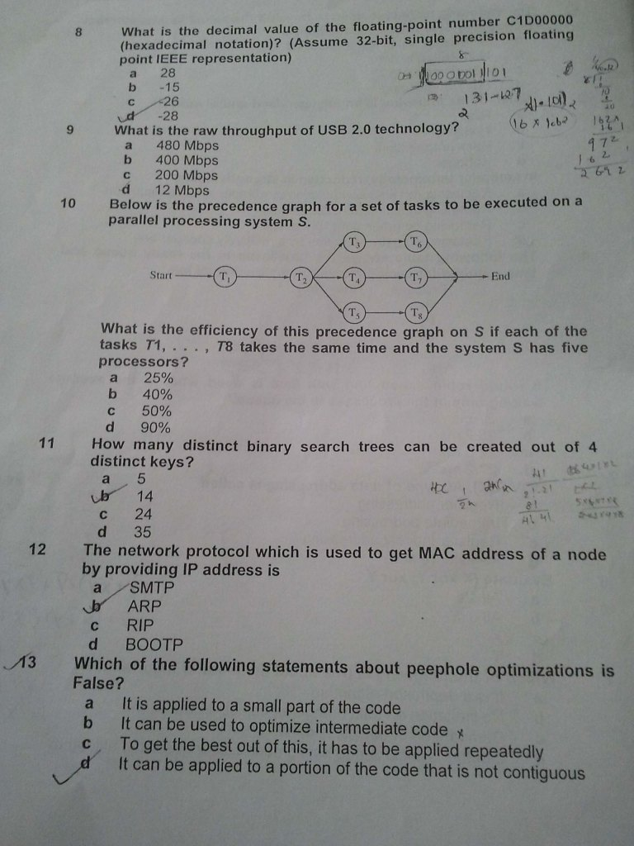](https://kurakar.files.wordpress.com/2013/03/2.jpg)

[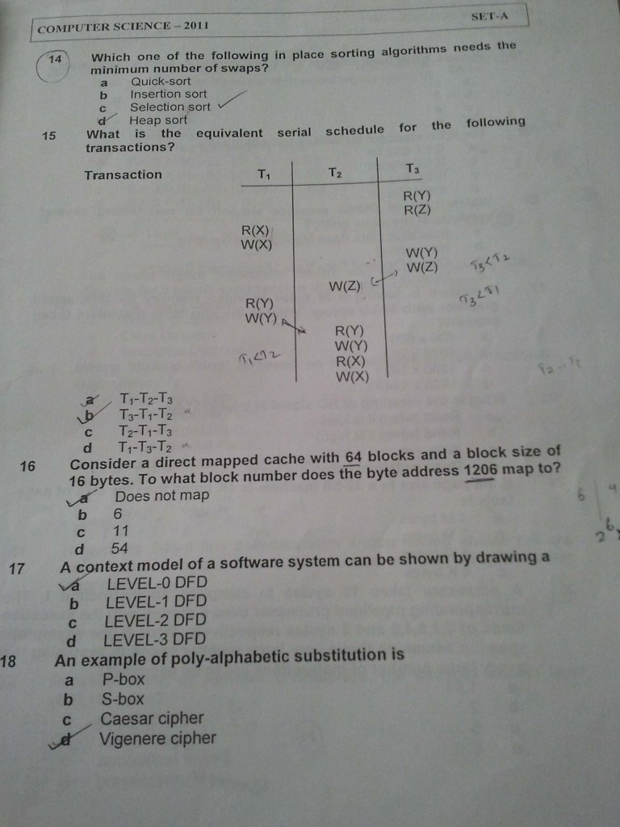](https://kurakar.files.wordpress.com/2013/03/3.jpg)

[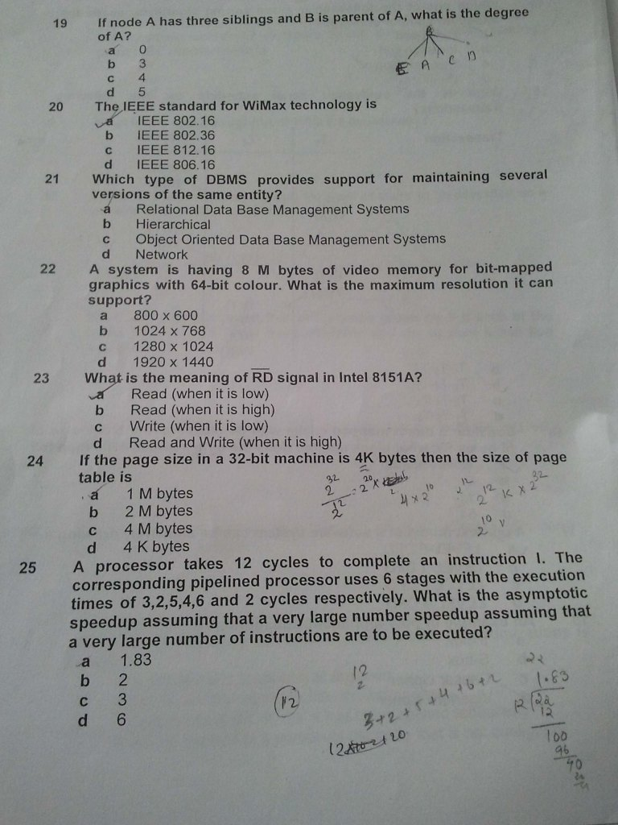](https://kurakar.files.wordpress.com/2013/03/4.jpg)

[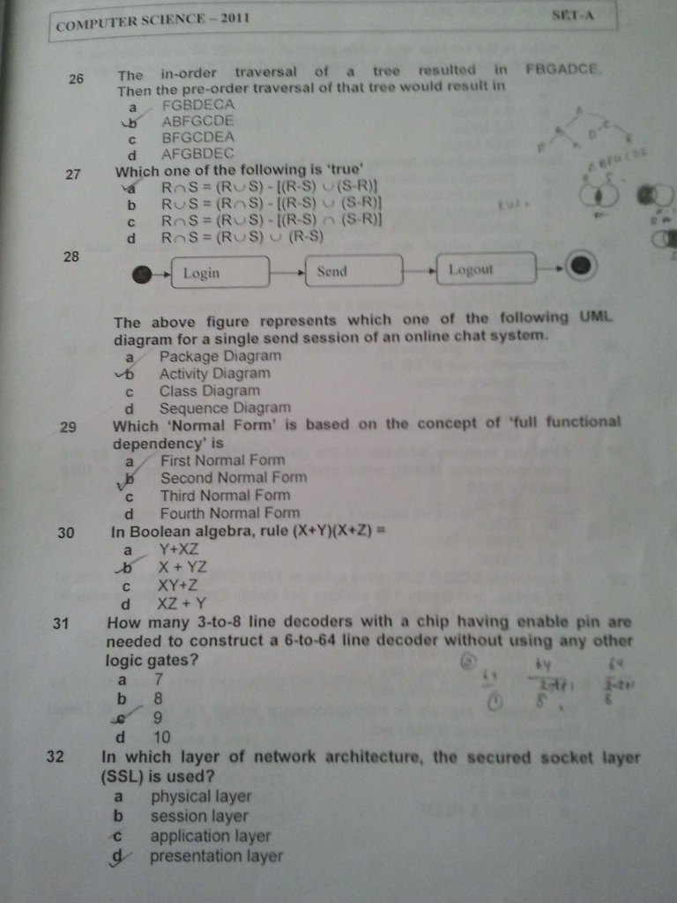](https://kurakar.files.wordpress.com/2013/03/5.jpg)

[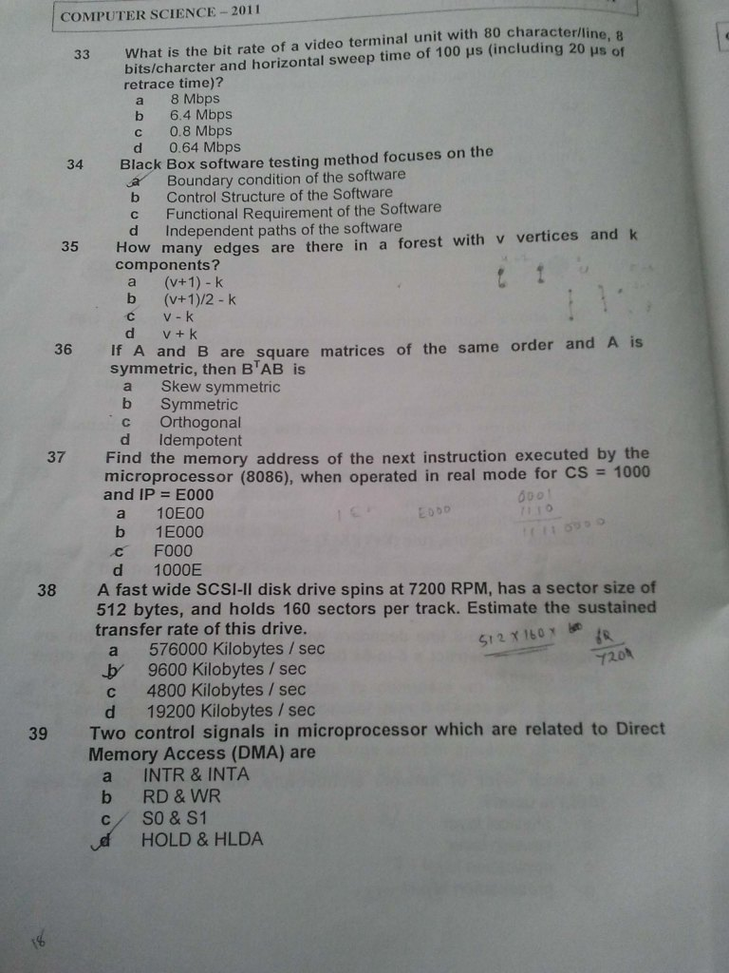](https://kurakar.files.wordpress.com/2013/03/6.jpg)

[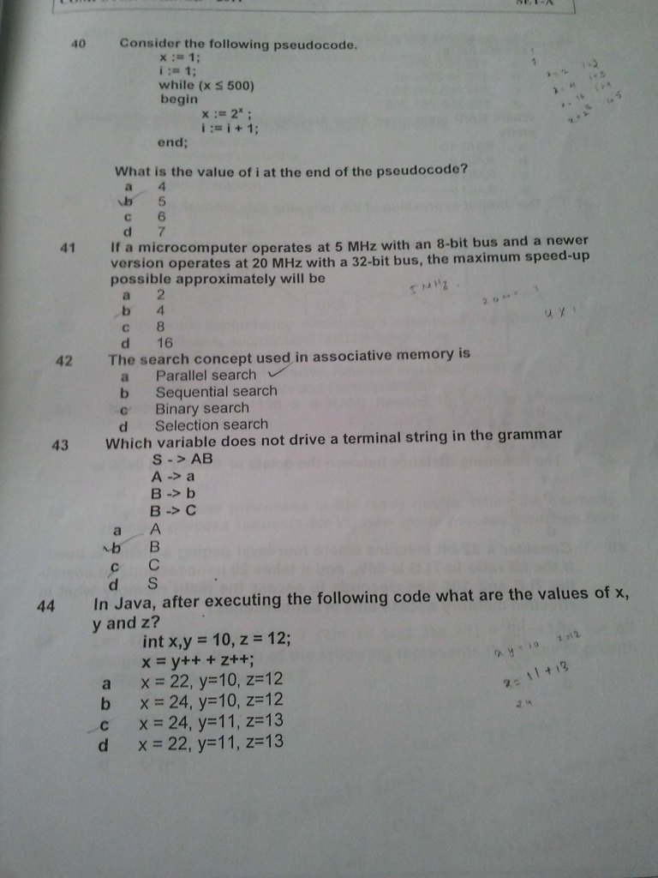](https://kurakar.files.wordpress.com/2013/03/7.jpg)

[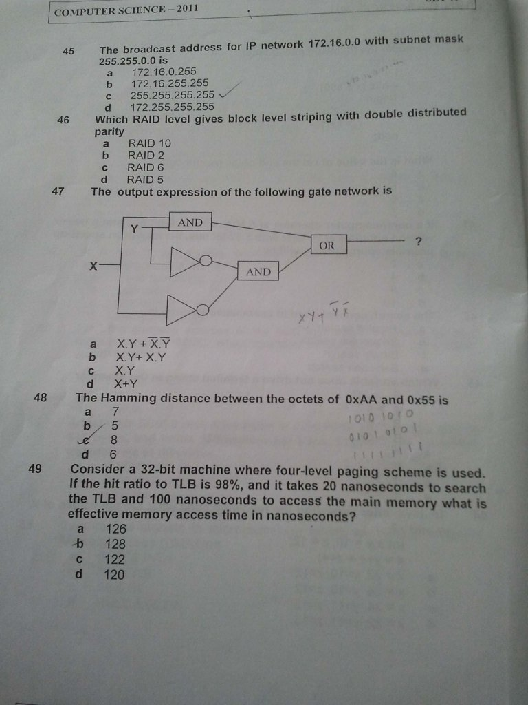](https://kurakar.files.wordpress.com/2013/03/8.jpg)

[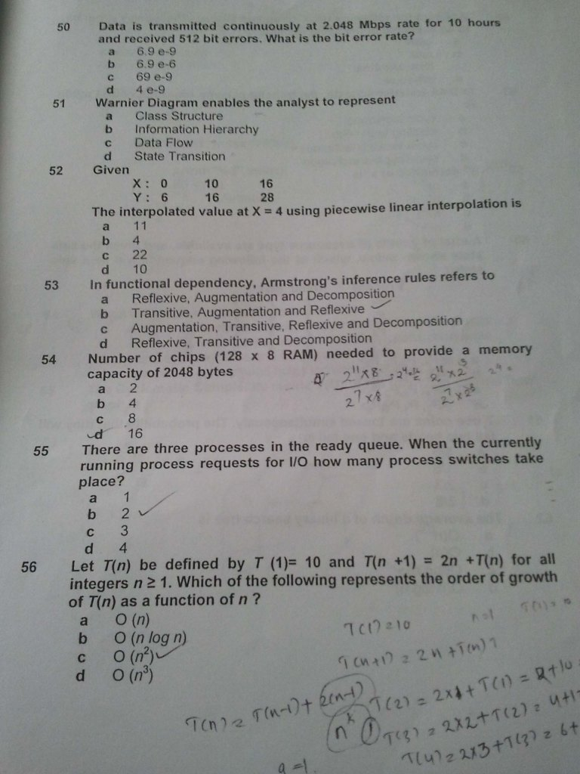](https://kurakar.files.wordpress.com/2013/03/9.jpg)

[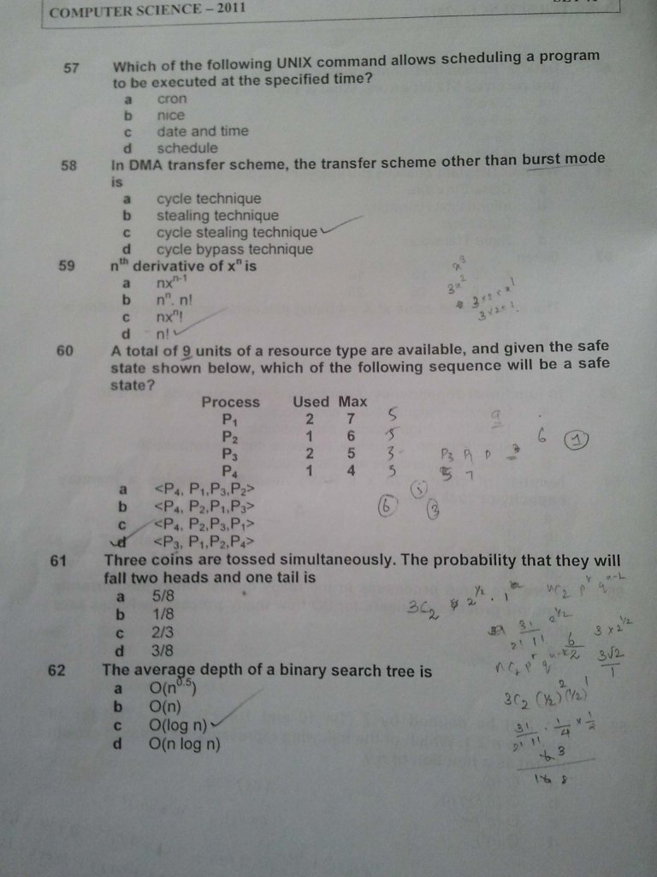](https://kurakar.files.wordpress.com/2013/03/10.jpg)

[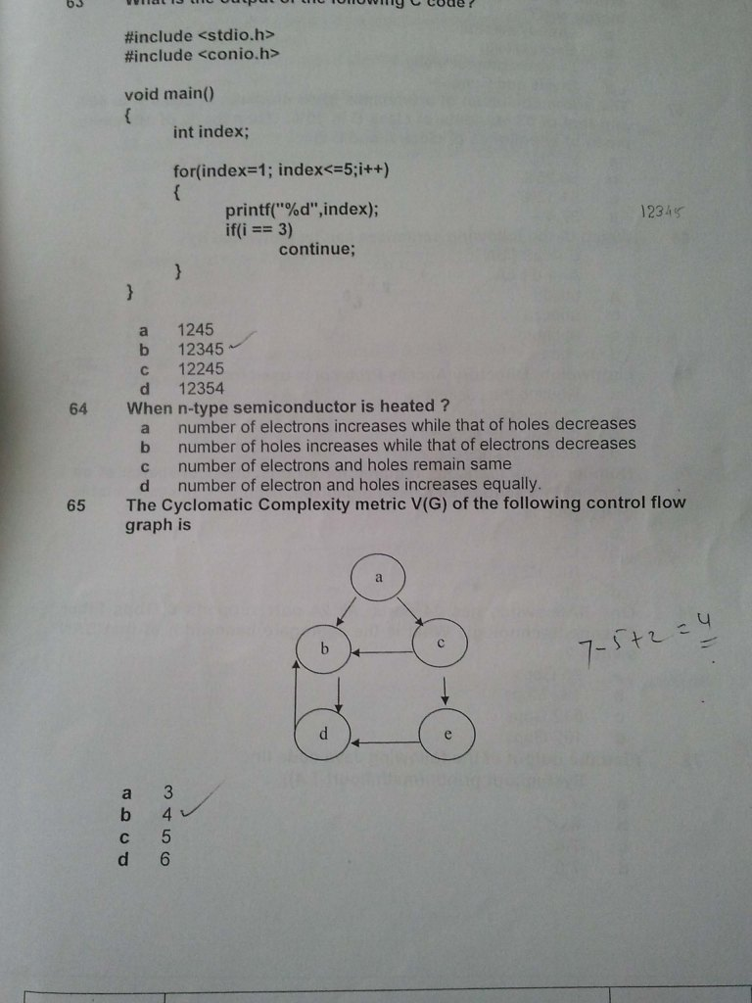](https://kurakar.files.wordpress.com/2013/03/11.jpg)

[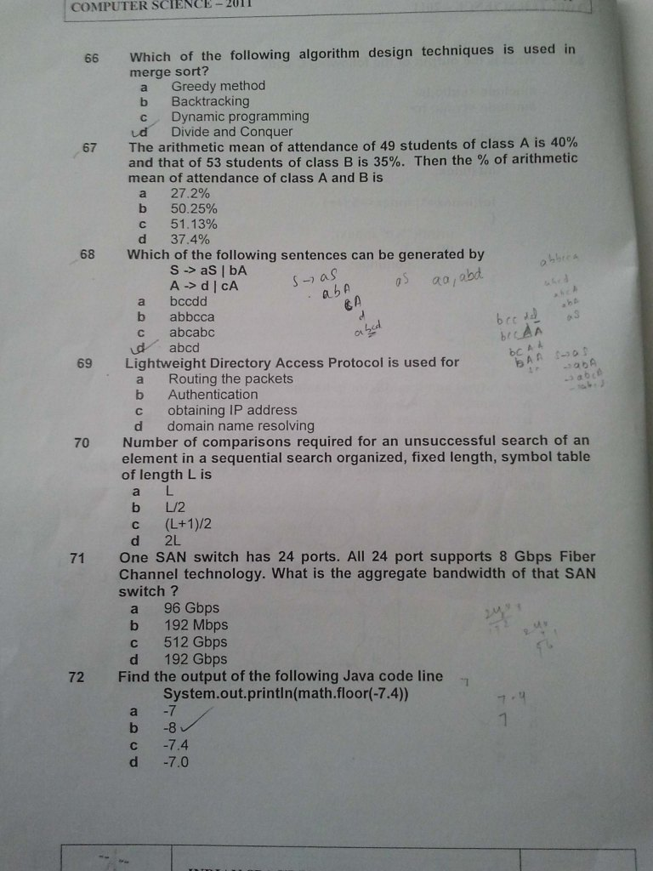](https://kurakar.files.wordpress.com/2013/03/12.jpg)

[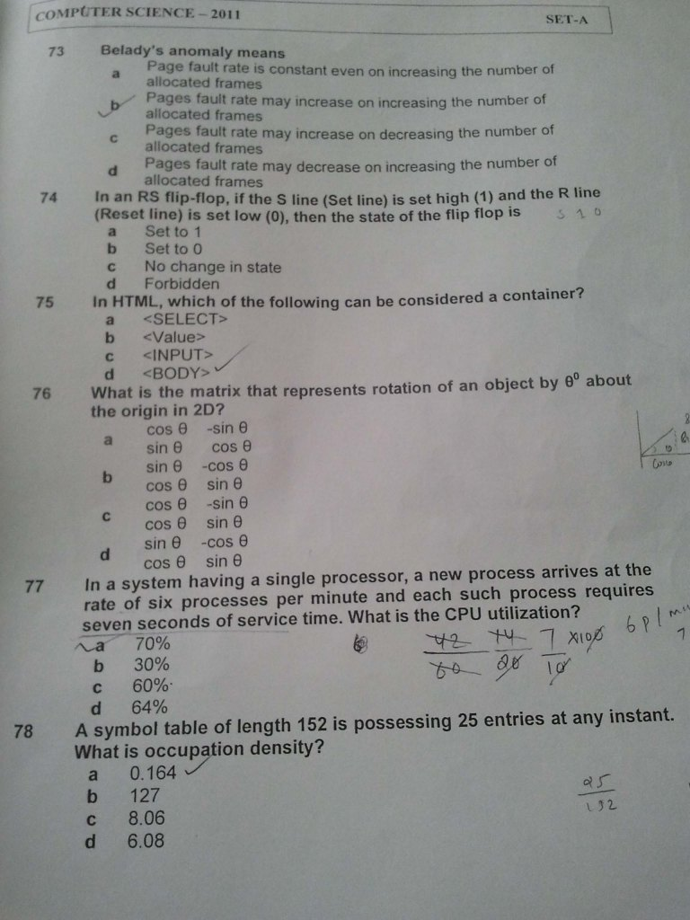](https://kurakar.files.wordpress.com/2013/03/13.jpg)

[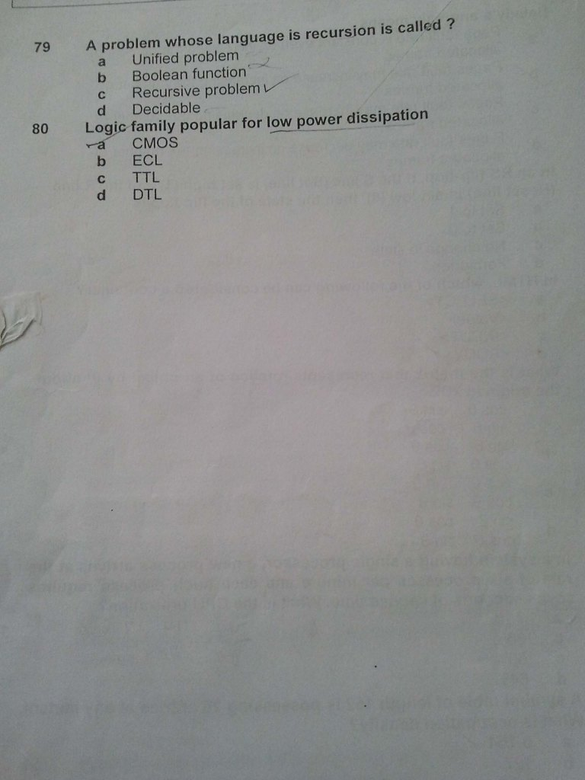](https://kurakar.files.wordpress.com/2013/03/14.jpg)

[About these ads](https://wordpress.com/about-these-ads/)

**Rate this:**

4 Votes

**Share this:**

* [Email](https://kurakar.wordpress.com/2013/03/04/isro-previous-paper-for-computer-science/?share=email&nb=1)
* [inShare](javascript:void(0);)

***Related***

[IIIT Hyderabad PG Admission 2013](https://kurakar.wordpress.com/2013/03/05/195/)In "PSU Exam"

[NICL Specialist Officer Exam 2013](https://kurakar.wordpress.com/2013/12/15/nicl-specialist-officer-exam-2013/)In "Technical"

[UPSC civil service notification 2013](https://kurakar.wordpress.com/2013/03/09/upsc-civil-service-notification-2013/)In "civil service"

[March 4, 2013](https://kurakar.wordpress.com/2013/03/04/isro-previous-paper-for-computer-science/) · Posted in [Uncategorized](https://kurakar.wordpress.com/category/uncategorized/) · Tagged [ISRO](https://kurakar.wordpress.com/tag/isro/), [previous papers](https://kurakar.wordpress.com/tag/previous-papers/)

**17 thoughts on “ISRO Previous paper for computer science”**

1. https://0.gravatar.com/avatar/cada74da532b62f371cd739483dfd31b?s=60&d=identicon&r=G**utsav ray**

[March 16, 2013 at 8:03 pm](https://kurakar.wordpress.com/2013/03/04/isro-previous-paper-for-computer-science/comment-page-1/#comment-14)

good work..can u pls give me the paper of 2010 and 11??

[Reply](https://kurakar.wordpress.com/2013/03/04/isro-previous-paper-for-computer-science/?replytocom=14#respond)

* 1. https://2.gravatar.com/avatar/5c4450370562952c67f55622976e3211?s=60&d=identicon&r=G**kurakar**

[March 17, 2013 at 8:59 am](https://kurakar.wordpress.com/2013/03/04/isro-previous-paper-for-computer-science/comment-page-1/#comment-15)

@utsav ray I think ISRO didn’t conduct exam for computer science graduate in the year 2010 and 2012. I will try uploading 2011 paper soon. Keep visiting

[Reply](https://kurakar.wordpress.com/2013/03/04/isro-previous-paper-for-computer-science/?replytocom=15#respond)

* + 1. https://2.gravatar.com/avatar/81c48b2d19db31eb09bf1abfc0a5470a?s=60&d=identicon&r=G**tushar**

[April 29, 2013 at 11:52 am](https://kurakar.wordpress.com/2013/03/04/isro-previous-paper-for-computer-science/comment-page-1/#comment-33)

please upload the 2011 Exam Ppaper

* + 1. https://1.gravatar.com/avatar/a8b19f921c36fb55bfedea2955e0d5a6?s=60&d=identicon&r=G**Gurpreet**

[May 28, 2014 at 2:19 pm](https://kurakar.wordpress.com/2013/03/04/isro-previous-paper-for-computer-science/comment-page-1/#comment-86)

Plz upload ISRO 2014 computer science question paper

1. https://0.gravatar.com/avatar/93ef30c397cc4e365f9923cc24e24b2f?s=60&d=identicon&r=G**Aravindh**

[April 3, 2013 at 6:31 am](https://kurakar.wordpress.com/2013/03/04/isro-previous-paper-for-computer-science/comment-page-1/#comment-24)

Hi Kurakar,  
Thanks for the info. Kindly try and upload CS2011 ISRO question paper  
if possible.

Thanks in advance

[Reply](https://kurakar.wordpress.com/2013/03/04/isro-previous-paper-for-computer-science/?replytocom=24#respond)

1. https://2.gravatar.com/avatar/54ab93cfbad6a84c6a64710e49daf4d8?s=60&d=identicon&r=G[**swetha**](http://nagappa)

[January 9, 2014 at 12:04 pm](https://kurakar.wordpress.com/2013/03/04/isro-previous-paper-for-computer-science/comment-page-1/#comment-67)

hi kurakar,  
can information science candidates also apply for this post.please reply

thanks in advance

[Reply](https://kurakar.wordpress.com/2013/03/04/isro-previous-paper-for-computer-science/?replytocom=67#respond)

* 1. https://2.gravatar.com/avatar/5c4450370562952c67f55622976e3211?s=60&d=identicon&r=G**Kurakar**

[January 11, 2014 at 10:55 pm](https://kurakar.wordpress.com/2013/03/04/isro-previous-paper-for-computer-science/comment-page-1/#comment-68)

Hi Swetha,  
To apply for Scientist computer science stream, in the advertisement it was mentioned that the applicant should be from B.Tech computer science. I think information science candidates may also be eligible, provided you should produce an equivalency certificate from the university authority. For more details, it would be better to contact ISRO directly.

Thanks for reading my blog

[Reply](https://kurakar.wordpress.com/2013/03/04/isro-previous-paper-for-computer-science/?replytocom=68#respond)

1. https://i2.wp.com/graph.facebook.com/100005767901504/picture?q=type%3Dlarge%26_md5%3D972e09bf92e6c13f6cc6c0e4425621a9&resize=60%2C60[**Babu Ranjan**](https://www.facebook.com/ranjanbabu.ravi)

[February 20, 2014 at 5:27 pm](https://kurakar.wordpress.com/2013/03/04/isro-previous-paper-for-computer-science/comment-page-1/#comment-70)

@ Kurakar sir, please upload 2013-question paper for computer science. And tell me some tips how to prepare for isro exam, as first time i am writing ISRO-2014 scientist engineer.

[Reply](https://kurakar.wordpress.com/2013/03/04/isro-previous-paper-for-computer-science/?replytocom=70#respond)

1. https://0.gravatar.com/avatar/c29ef5c0e494dc2dc0a9c7ab684958c5?s=60&d=identicon&r=G**Prashant Kumar**

[March 4, 2014 at 4:04 pm](https://kurakar.wordpress.com/2013/03/04/isro-previous-paper-for-computer-science/comment-page-1/#comment-74)

thank you for these papers

[Reply](https://kurakar.wordpress.com/2013/03/04/isro-previous-paper-for-computer-science/?replytocom=74#respond)

1. https://2.gravatar.com/avatar/80e439904a53343ae337850c23ed02ca?s=60&d=identicon&r=G[**Sweta Katkoria**](http://gravatar.com/swetakatkoria)

[May 11, 2014 at 12:57 pm](https://kurakar.wordpress.com/2013/03/04/isro-previous-paper-for-computer-science/comment-page-1/#comment-83)

Can you give me keys of ISRO CS papers 2007-08-09?

[Reply](https://kurakar.wordpress.com/2013/03/04/isro-previous-paper-for-computer-science/?replytocom=83#respond)

* 1. https://2.gravatar.com/avatar/eb5fd039bd597cfe6860a0d06901501f?s=60&d=identicon&r=G**avinash manegopale**

[July 10, 2015 at 11:26 am](https://kurakar.wordpress.com/2013/03/04/isro-previous-paper-for-computer-science/comment-page-1/#comment-114)

u got isro cs q paper solution 2009 2011 2013  
plz send email id :- [avinash.b.mane@gmail.com](mailto:avinash.b.mane@gmail.com) …….

[Reply](https://kurakar.wordpress.com/2013/03/04/isro-previous-paper-for-computer-science/?replytocom=114#respond)

1. https://1.gravatar.com/avatar/467558011388a344b21d897f57f683d4?s=60&d=identicon&r=G**rekha kharwar**

[August 16, 2014 at 1:41 pm](https://kurakar.wordpress.com/2013/03/04/isro-previous-paper-for-computer-science/comment-page-1/#comment-98)

pls give the qution paper 2010 2011  
2013 and also key

[Reply](https://kurakar.wordpress.com/2013/03/04/isro-previous-paper-for-computer-science/?replytocom=98#respond)

1. https://2.gravatar.com/avatar/8c82e4fa2589ab921510a5c8261ab867?s=60&d=identicon&r=G**Aarti**

[September 19, 2015 at 11:51 am](https://kurakar.wordpress.com/2013/03/04/isro-previous-paper-for-computer-science/comment-page-1/#comment-123)

Can u please post or mail me answer key of previous 5 years Question papers of CS ?

[Reply](https://kurakar.wordpress.com/2013/03/04/isro-previous-paper-for-computer-science/?replytocom=123#respond)

1. https://2.gravatar.com/avatar/ec32d57aa21f2984014c07982f1bd647?s=60&d=identicon&r=G**stella**

[May 17, 2016 at 1:12 pm](https://kurakar.wordpress.com/2013/03/04/isro-previous-paper-for-computer-science/comment-page-1/#comment-150)

pls send me answer keys 2007 2008 2009 and 2011 paper of scientist engineer for computer science

[Reply](https://kurakar.wordpress.com/2013/03/04/isro-previous-paper-for-computer-science/?replytocom=150#respond)

1. https://0.gravatar.com/avatar/9817811d13922575c8b04ed171b4817d?s=60&d=identicon&r=G**Jacob C.M.**

[June 2, 2016 at 1:28 pm](https://kurakar.wordpress.com/2013/03/04/isro-previous-paper-for-computer-science/comment-page-1/#comment-152)

Please send question papers of Computer Science applicants and keys

[Reply](https://kurakar.wordpress.com/2013/03/04/isro-previous-paper-for-computer-science/?replytocom=152#respond)

1. https://0.gravatar.com/avatar/cc354c83219a14a1df633492307c87a8?s=60&d=identicon&r=G**josephkj20**

[June 12, 2016 at 9:40 pm](https://kurakar.wordpress.com/2013/03/04/isro-previous-paper-for-computer-science/comment-page-1/#comment-154)

thanks Man

[Reply](https://kurakar.wordpress.com/2013/03/04/isro-previous-paper-for-computer-science/?replytocom=154#respond)

1. https://1.gravatar.com/avatar/1395a9e6a09d8d31b6973de057a2255b?s=60&d=identicon&r=G**Daphna**

[June 24, 2016 at 12:51 pm](https://kurakar.wordpress.com/2013/03/04/isro-previous-paper-for-computer-science/comment-page-1/#comment-155)

Where can I get the answer keys for CSE question papers

[Reply](https://kurakar.wordpress.com/2013/03/04/isro-previous-paper-for-computer-science/?replytocom=155#respond)

**Leave a Reply**

Top of Form



Bottom of Form

**Post navigation**

[« Intelligence Bureau(ACIO) Exam](https://kurakar.wordpress.com/2013/03/04/intelligence-bureauacio-exam/)

[IIIT Hyderabad PG Admission 2013 »](https://kurakar.wordpress.com/2013/03/05/195/)

[Create a free website or blog at WordPress.com.](https://wordpress.com/?ref=footer_website) · [The Edda Theme](https://wordpress.com/themes/edda/).

[Follow](javascript:void(0))

**Follow “My Blog”**

Top of Form

Get every new post delivered to your Inbox.

Bottom of Form

[Build a website with WordPress.com](https://wordpress.com/?ref=lof)